Applied Data Science 1

Assignment 1: Visualization

**GitHub URL:** <https://github.com/arsal575/Assgn1-US-cities-by-GDP-rank>

**DataSet URL:** <https://data.world/garyhoov/gdp-by-metro-area>

# GDP by Metro Area of US 2010-2015 Analysis:

US Metro Cities GDP is calculated and assigned to cities from 2010-2015 along with Overall Ranking of the cities and Growth Rate.

The data used to compile the Rankings comes from number of Sources such as from US Department of Economy the World Bank, and the Global Database for GDP and Growth.

1. **Line Graph of Overall Rank VS US Metro Cities**

Line Graph of 10 US Metro Cities is shown respectively to their overall Ranking in the US according to the GDP As we can see in the above graph generated from the data.

The Maximum GDP Ranking from these cities is of LA and the minimum GDP ranking is of OH.

1. **Comparative BarPlot of Overall Rank VS 2015 Rank**

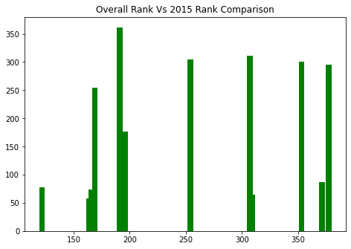

Comparative Barplot of 10 Cities Respective to their Overall Ranking and 2015 Rank respectively.

1. **Comparative ScatterPlot of 12 Metro Cities Vs Overall Rank**

We can see the Overall Ranking to US Metro Cities Data according to GDP, The Maximum Overall Rank is of LA and minimum GDP ranking of Auburn-Opelika, AL.

**Conclusion:**

The Ranking of US Metro Cities by GDP is shown in the above 3 graphs such as LinePlot, BarPlot and ScatterPlot. From the above Plots we can derive that the highest GDP ranking is of LA, after that is GA, NM, IA, TX, OR, NY respectively and the minimum Overall ranking is of OH according to GDP in the US Metropolitan Areas respectively.